Correlation Heatmap Analysis

Introduction

Correlation measures the strength and direction of the linear relationship between two variables, commonly applied to asset returns in quantitative finance. It plays a central role in understanding how assets move relative to one another and is widely used in portfolio construction, risk management, and factor analysis. In particular, correlation helps quantify diversification benefits and highlights how these benefits can diminish during periods of market stress, a phenomenon often referred to as correlation breakdown.

In practice, correlations are not static. They evolve over time as market conditions, investor behavior, and macroeconomic environments change. As a result, static correlation estimates can be misleading, especially during regime shifts such as financial crises or sudden risk repricing events.

Mathematical Background

The most commonly used measure of correlation in finance is the Pearson correlation coefficient, defined as:
$$ρ_{X,Y}=\frac{\text{Cov}(X,Y)}{σ_{X}σ_{Y}}$$
where:
- $ρ_{X,Y}∈[-1,1]$
- $+1$ indicates perfect positive correlation
- $0$ indicates no linear relationship
- $-1$ indicates perfect negative correlation

This measure captures the degree to which two asset returns move together on a linear basis and forms the foundation for correlation-based risk analysis.

Motivation and Objectives

The objective of this project is to construct a dynamic correlation heatmap across multiple asset classes, including equity indices, foreign exchange pairs, interest rates, and commodities. By applying rolling correlation windows, we aim to observe how inter-asset relationships evolve through time rather than relying on static averages.

A key motivation is to compare correlation structures during calm market conditions versus stress periods. During market drawdowns, correlations often rise sharply as investors de-risk simultaneously, reducing diversification benefits precisely when they are most needed. Visualizing these dynamics allows us to better understand systemic risk and cross-asset contagion

Correlation Heatmaps as a Research Tool

Correlation heatmaps provide an intuitive and compact visualization of pairwise relationships across a large set of assets. Each cell in the heatmap represents the correlation between two assets at a given point in time, with color intensity indicating the strength and direction of the relationship. When extended dynamically using rolling windows, heatmaps become a powerful diagnostic tool:
- Rising correlations across asset classes can signal risk-off regimes
- Stable or low correlations are often associated with risk-on environments
- Sudden shifts in correlation structure may act as early warning signals of regime transitions

By annotating these heatmaps with known macroeconomic or financial stress events, we can directly link changes in correlation behavior to broader market regimes.

Market Regimes and Risk Framework

To interpret the observed correlation dynamics, we adopt a risk-on / risk-off framework. Risk-on regimes are typically characterized by lower cross-asset correlations and greater dispersion in returns, reflecting selective risk-taking by investors. In contrast, risk-off regimes exhibit elevated correlations as capital moves defensively and assets begin to trade more uniformly. The following table summarizes key market regimes used in this analysis and how they align with the risk-on and risk-off classification.

Regime | Typical Environment | Market Characteristics | Assets That Tend to Perform Well | Assets That Tend to Underperform
Risk-On | Economic growth, easy financial conditions | Rising equities, low volatility, tight credit spreads | Equities (growth, EM), high-yield credit, commodities | Government bonds, gold, safe-haven FX
Risk-Off | Crisis, uncertainty, tightening conditions | Equity sell-offs, volatility spikes, correlations converge | Government bonds, gold, USD, JPY, defensive equities | Equities, high-yield credit, EM assets

Dataset and Parameters

For this analysis, we consider four major asset classes: Stocks, FX pairs, Rates, and Commodities. Each asset class exhibits unique factor sensitivities and dynamics, providing a diverse set of behaviors across different market environments. This diversity allows us to capture a wide range of responses to risk-on and risk-off events, making the analysis of rolling correlations and dynamic heatmaps more insightful and robust.

As for the period of analysis, we will be taking data from 2020 to 2025, with the data source being from Yahoo Finance.
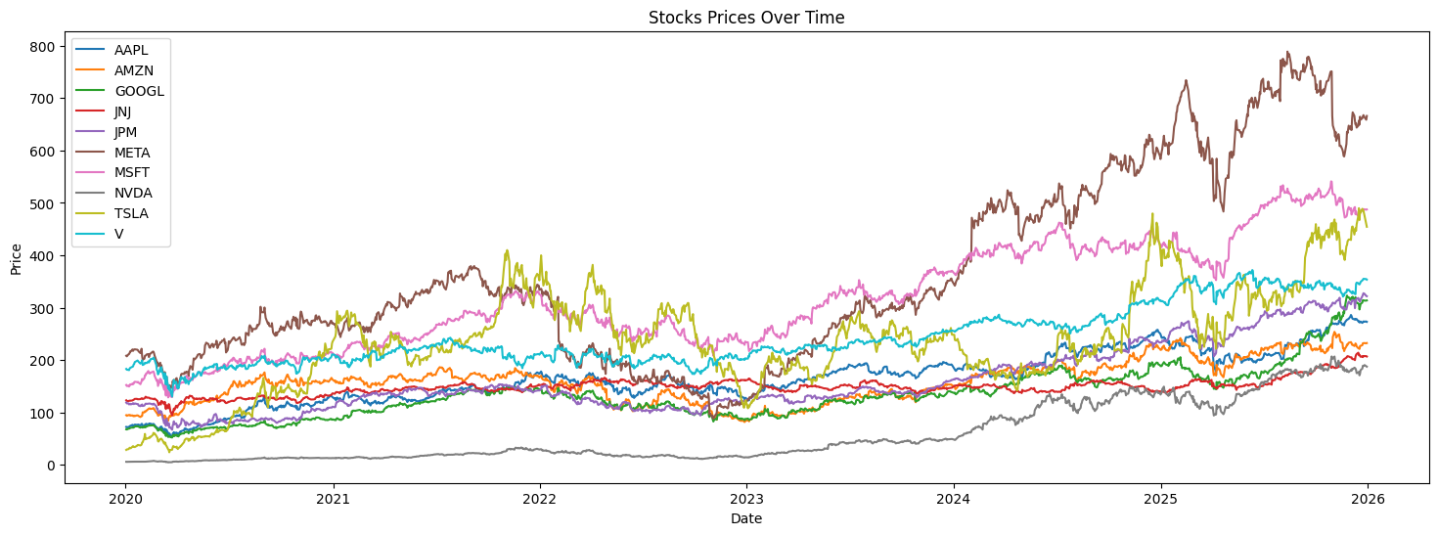
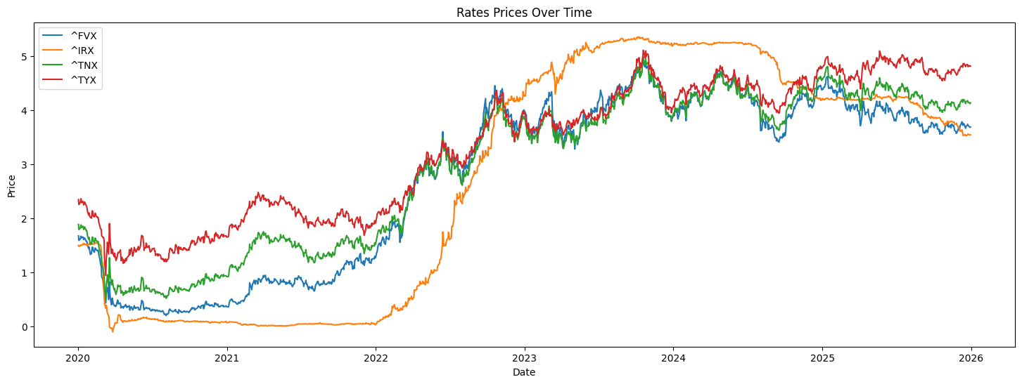
We plotted the charts above for stocks and rates so as to get a preliminary idea of how they have performed or move over time.

Rolling Correlation

The rolling correlation differs from our normal asset correlation, in that instead of computing correlation across the entire period, we are using a rolling window function to compute the correlation of the assets during those period. Mathematically, it can be defined as follow:

$$ρ_{t}^{\left(X, Y\right)}=\frac{\sum_{i=0}^{n-1}{\left(X_{t-i }-{\overline{X}}_{t}\right)\left(Y_{t-i }-Y_{t}\right)}}{\sqrt{\sum_{i=0}^{n-1}{{\left(X_{t-i }-{\overline{X}}_{t}\right)}^{2}}}\sqrt{\sum_{i=0}^{n-1}{{\left(Y_{t-i }-{\overline{Y}}_{t}\right)}^{2}}}}$$

Where:
- $n$: the rolling window length
- ${\overline{X}}_{t}=\frac{1}{n}\sum_{i=0}^{n-1}{X_{t-i }}$ is the rolling mean of $X_{t}$
- ${\overline{Y}}_{t}=\frac{1}{n}\sum_{i=0}^{n-1}{Y_{t-i }}$ is the rolling mean of $Y_{t}$

Using the above formula, we computed our rolling correlations using a 30-day lookback window period. This means we are deriving the correlation across all the tickers within the asset class over the past 30-days.

Using Matplotlib FuncAnimation, we were able to produce a dynamic correlation heatmap of all the tickers within each asset class. Refer to the notebook for usage.

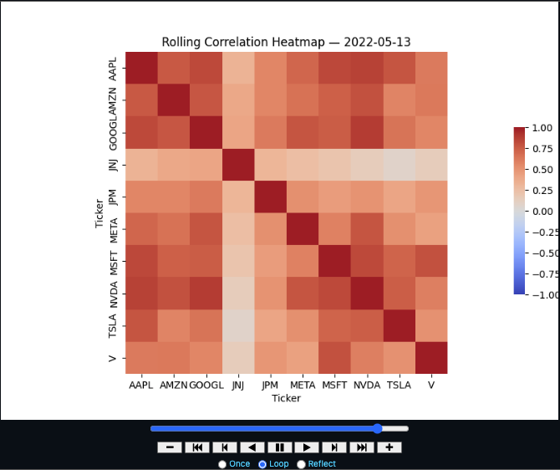

Explore the notebook and change the lookback periods or ticker symbols to see how the correlation changes over time.
Average Rolling Correlation

While rolling correlations provide pairwise measures of how two assets move together over time, analysing all pairwise correlations individually can quickly become overwhelming, especially when dealing with large multi-asset portfolios. Each rolling correlation series tells you about one relationship, but it can be difficult to extract a broader, high-level view of market behaviour from hundreds or thousands of pairwise correlations. I mean, it is nice to see the animated charts for rolling correlation, but it does not answer the broader questions in risk-management.

To address this, we compute the average rolling correlation across all assets in a given asset class or portfolio. Mathematically, for a set of $N$ assets with rolling correlations $ρ_{i,j}(t)$ at time $t$, the average rolling correlation is:
$$\overset{ˉ}{ρ}(t)=\frac{2}{N(N-1)}\sum_{i<j}{ρ_{i,j}}(t)$$
You can think of the above formula as taking the average of the correlation values in our upper/lower triangle (in blue) inside our correlation matrix.

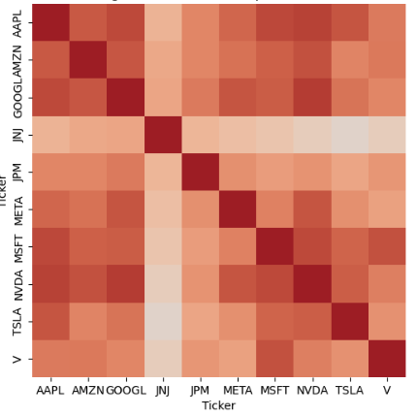
This average gives a single time series that summarizes the overall co-movement of the entire portfolio or asset class. For our python code, we simply took the average of all the correlation values (less the diagonals) using the snippet below.

Computing the rolling mean correlations and plotting the values over time, we got the following charts for each of our asset classes. We also included some risk-off and macro-shocks that heightened overall volatility to show how correlation may move.

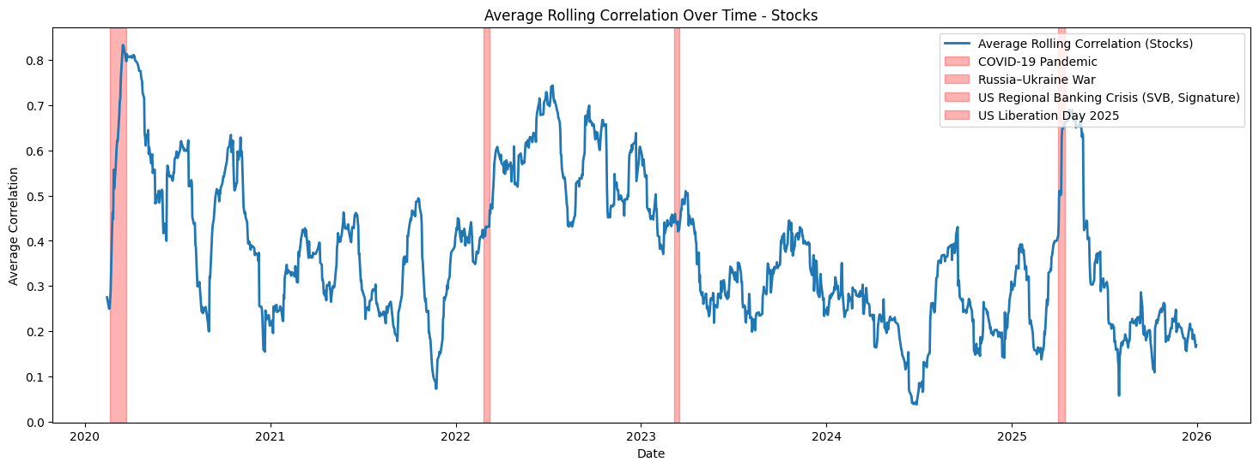
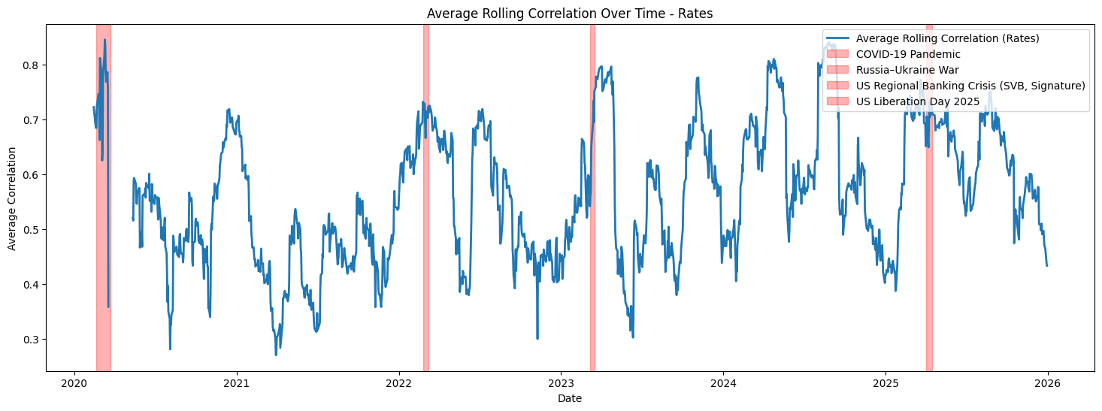
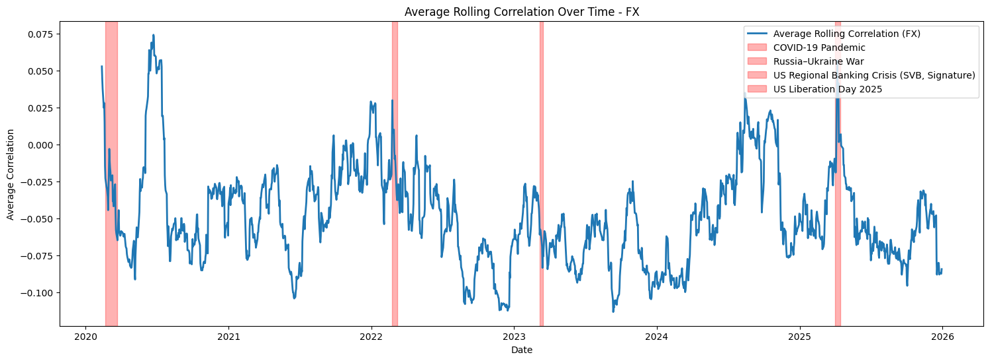
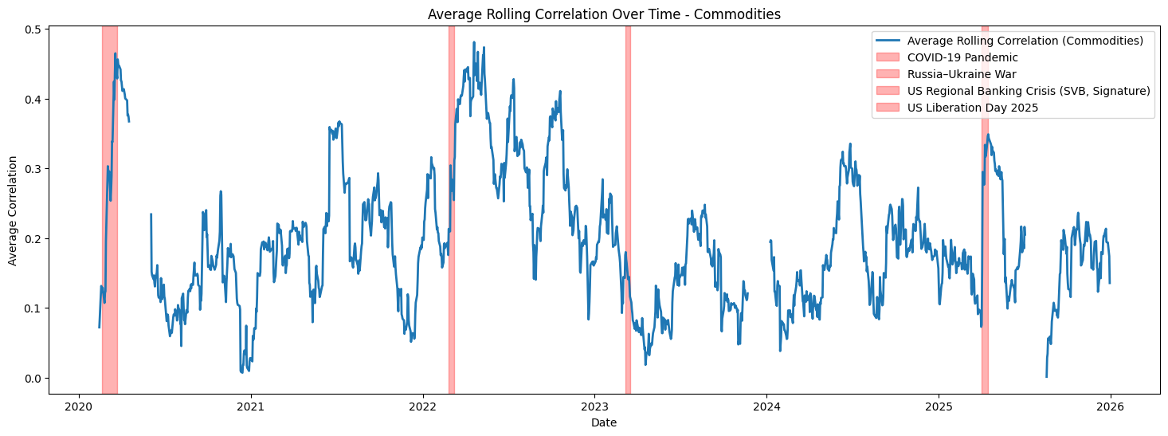

As observed, stocks and interest rates generally exhibit higher correlations during risk-off periods, reflecting strong co-movement across asset classes in times of market stress. During macroeconomic shocks, correlations among stocks tend to increase as broad market factors dominate company-specific fundamentals. In such periods, investors often reduce equity exposure across the board, prioritizing safety over stock-specific considerations, as equities are typically riskier than other assets such as bonds.

The second chart highlights that interest rates also show strong correlations, often in the range of 0.7 to 0.8, during risk-off regimes. The rates in this analysis represent U.S. Treasury yields of varying maturities, which serve as benchmark interest rates in financial markets. During periods of uncertainty, Treasury yields tend to move together due to shifts in monetary policy expectations, flight-to-quality flows, or changes in risk sentiment.

In contrast, FX pairs generally exhibit lower correlations with one another, indicating that currency movements are influenced by a broader set of idiosyncratic and cross-border factors, rather than moving strictly in unison during stress periods.

A similar pattern is observed for commodities, where correlations can vary significantly across different products. While some commodities may respond to global macroeconomic shocks in a coordinated manner, others remain more asset-specific, reflecting supply-demand dynamics, geopolitical events, or seasonal factors. Our commodity bucket consists of Gold, Silver, Crude-oil, Natural Gas, Copper, Corn and Soybeans, which could explain why correlation varies to a large extent: precious metals like gold and silver tend to move together as safe-haven assets during market stress, energy commodities such as crude oil and natural gas are influenced by global demand, supply constraints, and geopolitical tensions, while agricultural products like corn and soybeans respond to crop yields, weather conditions, and trade policies. As a result, the overall correlation structure within commodities is a complex mix of macro-driven co-movement and asset-specific dynamics.

Rolling Correlation Analysis

We will now study how a given asset of our choice correlates with their peers on a rolling basis. A few tweaks to our existing code would do the job. On top of that, we can also group by the asset class or sectors to see whether correlation exists on a sector and class level.

1. Cross-sectional or inter-asset analysis

2. Sectoral or Industry specific analysis

